Private College Transactions. Elizabeth College, a small private college, had the following transactions in fiscal year 2011.

1. Billings for tuition and fees totaled $5,600,000. Tuition waivers and scholarships of $61,500 were granted. Students received tuition refunds of $101,670.
2. During the year the college received $1,891,000 cash in unrestricted private gifts, $575,200 cash in temporarily restricted grants, and $1,000,000 in securities for an endowment.
3. A pledge campaign generated $626,000 in unrestricted pledges, payable in fiscal year 2012.
4. Auxiliary enterprises provided goods and services that generated $94,370 in cash.
5. Collections of tuition receivable totaled $5,380,000.
6. Unrestricted cash of $1,000,000 was invested.
7. The college purchased computer equipment at a cost of $10,580.
8. During the year the following expenses were paid:
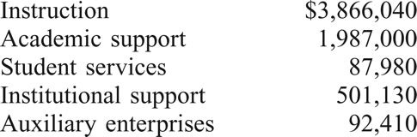
9. Instruction provided $450,000 in services related to the temporarily restricted grant recorded in transaction 2.
10. At year-end, the allowance for uncollectible tuition and fees was increased by $7,200. The fair value of investments had increased $11,540; of this amount, $3,040 was allocated to permanently restricted net assets, the remainder was allocated to unrestricted net assets. Depreciation on plant and equipment was allocated $34,750 to instruction, $41,000 to auxiliary enterprises, and $12,450 to academic support.
11. All nominal accounts were closed.

Required

a. Prepare journal entries in good form to record the foregoing transactions for the fiscal year ended June 30, 2011.
b. Prepare a statement of activities for the year ended June 30, 2011. Assume beginning net asset amounts of $7,518,000 unrestricted, $200,000 temporarily restricted, and $5,000,000 permanently restricted.

16–4 Public University Transactions. The Statement of Net Assets of Green Tree State University, a governmentally owned university, as of the end of its fiscal year June 30, 2010, follows.
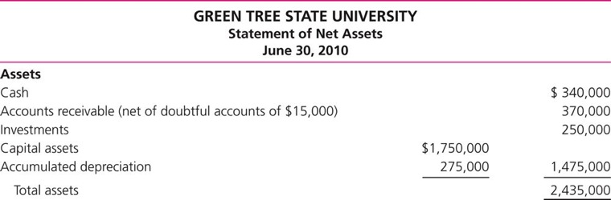

The following information pertains to the year ended June 30, 2011:

1. Cash collected from students’ tuition totaled $3,000,000. Of this $3,000,000, $362,000 represented accounts receivable outstanding at June 30, 2010; $2,500,000 was for current-year tuition; and $138,000 was for tuition applicable to the semester beginning in August 2011.
2. Deferred revenue at June 30, 2010, was earned during the year ended June 30, 2011.
3. Notification was received from the federal government that up to $50,000 in funds could be received in the current year for costs incurred in developing student performance measures.
4. During the year, the University received an unrestricted appropriation of $60,000 from the state.
5. Equipment for the student computer labs was purchased for cash in the amount of $225,000.
6. During the year, $200,000 in cash contributions was received from alumni. The contributions are to be used for construction of a new library.
7. Interest expense on the bonds payable in the amount of $48,000 was paid.
8. During the year, investments with a carrying value of $25,000 were sold for $31,000. Investments were purchased at a cost of $40,000. Investment income of $18,000 was earned and collected during the year.
9. General expenses of $2,500,000 related to the administration and operation of academic programs, and research expenses of $37,000 related to the development of student performance measures were recorded in the voucher system. At June 30, 2011, the accounts payable balance was $75,000.
10. Accrued liabilities at June 30, 2010, were paid.
11. At year-end, adjusting entries were made. Depreciation on capital assets totaled $90,000. Accrued interest on investments was $1,250. The fair value of investments at year-end was $262,000. The Allowance for Doubtful Accounts was adjusted to $17,000.
12. Nominal accounts were closed and net asset amounts were reclassified as necessary.

Required

a. Prepare journal entries in good form to record the foregoing transactions for the year ended June 30, 2011.
b. Prepare a statement of net assets for the year ended June 30, 2011.

